Uniform orders must be placed by July 10th 2017. Please see Norma in the Pumas office to place the order and sizing. Payment needed in full when placing order.
- 2017 Mandatory Kit: $155
  - Home and Away Jerseys
  - Two shorts
  - Two pairs of socks
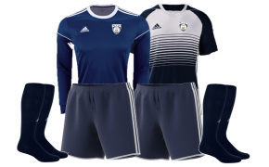
- Add-Ons:
  - Adidas Backpack includes logo, name and number: $75
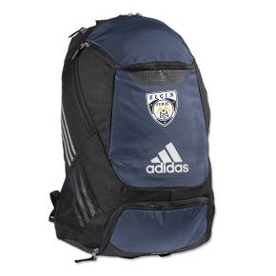
  - Warm up includes logo on the jacket and number on the pants: $118
